Understanding SAP Signavio Process Manager
Objective
After completing this lesson, you will be able to use SAP Signavio Process Manager and apply its features.
Understanding SAP Signavio Process Manager
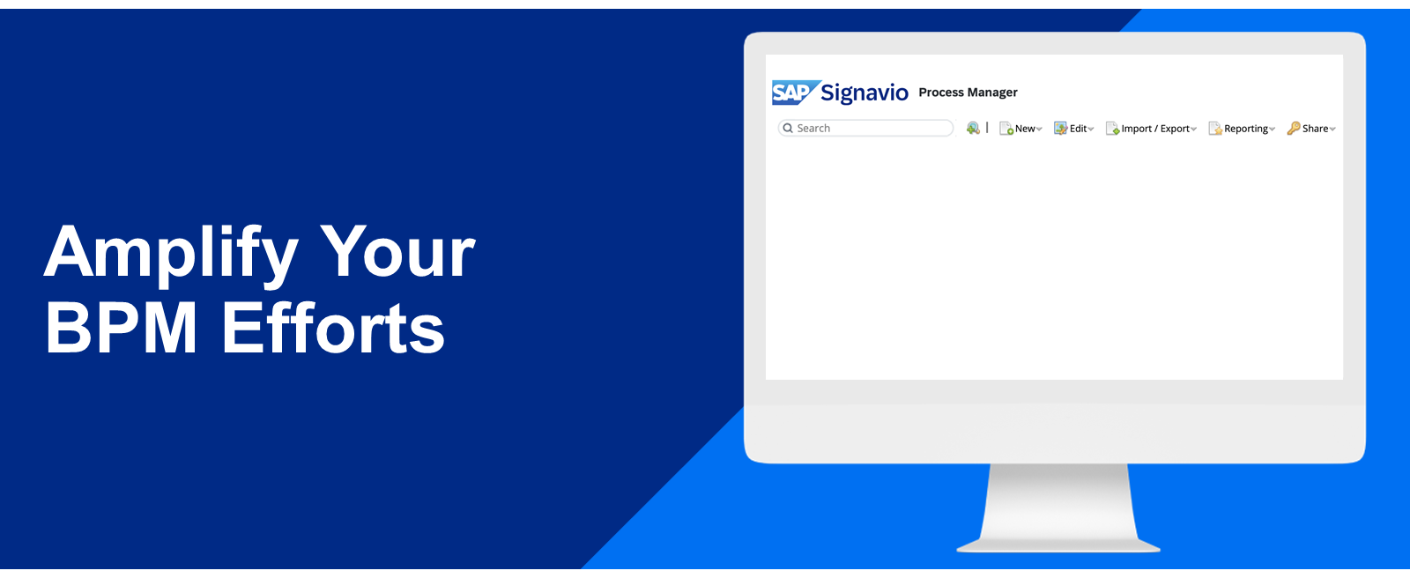
Orchestrating Business Processes
In a company, every person has a certain role and unique tasks to fulfill. In their daily work, members of organizations use a variety of tools as well as great amounts of data as they contribute to business processes. You could compare the workings of a company to those of an orchestra; There are the skilled musicians, the high-quality instruments, and the correct sheets of music. Last but not least, there's the maestro who ensures the performance runs smoothly. We know that orchestrating is no easy task, and that's why SAP Signavio Process Manager is here to support you with it.
Before we go further into detail, watch the following video to get an overview of the solution and its functions.
SAP Signavio Process Manager: Features and Benefits
The purpose of modeling business processes is to build companywide understanding. Only when clearly captured can processes be improved. This includes not only the main steps, but also the business objects used. Additionally, the importance of the employees and their input can't be forgotten. That's why the Process Manager focuses on:
- Process Documentation (the Explorer and the Editor)
- Process and Object Management (the Dictionary)
- Process Publishing, Collaboration, Feedback Handling
- Process Analysis (Simulation and Reporting)
Below, you can find a more detailed list of the solution’s features. All of them come together and support you in efficient business process management:
- A central modeling component to easily create various types of diagrams.
- An attribute functionality to capture additional information on processes and tasks.
- A folder structure to store and quickly find processes.
- A version control functionality to reverse changes when needed.
- A central object repository to reuse the same business terms across all processes.
- A commenting feature to provide feedback and collaborate on processes.
- A diagram comparison functionality to contrast the As-Is with the To-Be model.
- A reporting functionality to aggregate information on selected processes.
Hint
To get started, all you need is a browser and an internet connection. You don't need to install any software.

